Labaratoriya 14

Formani JavaScript orqali tekshirish (validation)

KIRISH
Hozirgi kunda web-saytlar orqali turli shakllar (formalar) yordamida ro‘yxatdan o‘tish, login qilish, ma’lumot yuborish kabi jarayonlar keng qo‘llaniladi. Foydalanuvchi kiritgan ma’lumotning to‘g‘ri, to‘liq va xavfsiz bo‘lishini ta’minlash uchun forma validatsiyasi juda muhim hisoblanadi. Validatsiya — bu foydalanuvchi kiritgan ma’lumotlarni tekshirish jarayoni bo‘lib, ma’lumot serverga yuborilishidan oldin undagi xatolarni aniqlab, to‘g‘rilash imkonini beradi.
JavaScript forma validatsiyasi – bu ma’lumotlarni brauzer tarafida (client-side) tekshirish bo‘lib, u foydalanuvchilar uchun qulaylik yaratadi va serverga bo‘lgan ortiqcha yukni kamaytiradi.

ASOSIY QISM

1. Forma validatsiyasining maqsadi
JavaScript orqali forma tekshirilishi quyidagi vazifalarni bajaradi:
Noto‘g‘ri yoki bo‘sh ma’lumotlarni serverga yuborishni oldini oladi.
Foydalanuvchidan aniq va to‘liq ma’lumot kiritilishini ta’minlaydi.
Sayt xavfsizligini oshiradi.
Foydalanuvchiga xatolik haqida darhol ogohlantirish beradi.

2. Validationning turlari

1. Majburiy maydonlarni tekshirish
if (name.value === "") {
alert("Ism kiriting!");
}

2. Email formatini tekshirish
let emailPattern = /^[^\s@]+@[^\s@]+\.[^\s@]+$/;if (!emailPattern.test(email.value)) {
alert("Email noto‘g‘ri!");
}

3. Parol uzunligini tekshirish
if (password.value.length < 6) {
alert("Parol kamida 6 ta belgidan iborat bo‘lishi kerak.");
}

4. Telefon raqamni tekshirish
let phonePattern = /^[0-9]{9,12}$/;

5. Bir-biriga mos ma’lumotlar
Masalan, “Parol” va “Parolni tasdiqlash” mosligini tekshirish:
if (password.value !== confirmPassword.value) {
alert("Parollar mos emas!");
}

3. JavaScriptda to‘liq forma tekshirish misoli
<form onsubmit="return validateForm()">
Ism: <input type="text" id="name"><br>
Email: <input type="text" id="email"><br>
Parol: <input type="password" id="password"><br><br>
<button type="submit">Yuborish</button></form>
<script>function validateForm() {
let name = document.getElementById("name");
let email = document.getElementById("email");
let password = document.getElementById("password");

if (name.value === "") {
alert("Ism bo‘sh bo‘lmasligi kerak!");
return false;
}

let emailPattern = /^[^\s@]+@[^\s@]+\.[^\s@]+$/;
if (!emailPattern.test(email.value)) {
alert("Email noto‘g‘ri kiritilgan!");
return false;
}

if (password.value.length < 6) {
alert("Parol kamida 6 belgidan iborat bo‘lsin!");
return false;
}

return true;
}</script>
Amaliy qism:

Quramboyeva, [19.12.2025 10:15]
<!DOCTYPE html>
<html lang="uz">
<head>
<meta charset="UTF-8">
<title>🌸 Gul Do‘koni</title>

<style>
body {
margin: 0;
font-family: 'Poppins', sans-serif;
background: linear-gradient(135deg, #fde0dc, #fce4ec);
}

header {
text-align: center;
padding: 30px;
background: #d81b60;
color: white;
border-bottom-left-radius: 25px;
border-bottom-right-radius: 25px;
}

h1 {
margin: 0;
font-size: 36px;
}

header p {
margin-top: 8px;
font-size: 17px;
}

.items {
display: grid;
grid-template-columns: repeat(3, 1fr);
gap: 25px;
padding: 40px;
}

.item {
background: white;
border-radius: 20px;
overflow: hidden;
box-shadow: 0 6px 18px rgba(0,0,0,0.2);
transition: 0.3s;
}

.item:hover {
transform: translateY(-8px);
}

.item img {
width: 100%;
height: 220px;
object-fit: cover;
}

.content {
padding: 15px;
}

.title {
font-size: 22px;
color: #880e4f;
margin: 0;
}

.type {
font-weight: bold;
color: #c2185b;
margin-top: 5px;
}

.desc {
margin-top: 10px;
color: #424242;
}

.order {
max-width: 650px;
background: white;
margin: 40px auto;
padding: 30px;
border-radius: 20px;
box-shadow: 0 6px 18px rgba(0,0,0,0.2);
}

.order h2 {
text-align: center;
color: #d81b60;
}

label {
font-weight: bold;
display: block;
margin-top: 15px;
}

input, select {
width: 100%;
padding: 12px;
margin-top: 6px;
border-radius: 10px;
border: 1px solid #ccc;
font-size: 15px;
}

button {
width: 100%;
margin-top: 25px;
padding: 14px;
background: #d81b60;
color: white;
font-size: 16px;
border: none;
border-radius: 12px;
cursor: pointer;
}

button:hover {
background: #ad1457;
}

.flower-box {
display: grid;
grid-template-columns: repeat(3, 1fr);
gap: 12px;
margin-top: 10px;
}

.flower-card {
background: #fff0f6;
border: 2px solid #f8bbd0;
border-radius: 12px;
padding: 12px;
text-align: center;
cursor: pointer;
transition: 0.3s;
font-weight: bold;
color: #880e4f;
}

.flower-card input {
display: none;
}

.flower-card:hover {
background: #fce4ec;
}

.flower-card input:checked + span {
background: #d81b60;
color: white;
padding: 6px 10px;
border-radius: 8px;
display: inline-block;
}

@media (max-width: 900px) {
.items {
grid-template-columns: repeat(2, 1fr);
}
.flower-box {
grid-template-columns: repeat(2, 1fr);
}
}

@media (max-width: 600px) {
.items {
grid-template-columns: 1fr;
padding: 20px;
}
.flower-box {
grid-template-columns: 1fr;
}
}
</style>
</head>

<body>

<header>
<h1>🌸 Gul Do‘koni</h1>
<p>Eng yangi va chiroyli gullar</p>
</header>

<section class="items">
<div class="item">
<img src="rasim 4.jpg" alt="Atirgul">
<div class="content">
<h3 class="title">Atirgullar</h3>
<p class="type">Romantik</p>
<p class="desc">Qizil va oq atirgullar.</p>
</div>
</div>

<div class="item">
<img src="rasim 2.jpg" alt="Lola">
<div class="content">
<h3 class="title">Lolalar</h3>
<p class="type">Bahor gullari</p>
<p class="desc">Rang-barang lolalar.</p>
</div>
</div>

<div class="item">
<img src="rasim 3.jpg" alt="Buket">
<div class="content">
<h3 class="title">Buketlar</h3>
<p class="type">Maxsus buyurtma</p>
<p class="desc">Bayramlar uchun buketlar.</p>
</div>
</div>

</section>

<section class="order">
<h2>🛒 Buyurtma berish</h2>

<form onsubmit="sendOrder(event)">
<label>Ism</label>
<input type="text" required placeholder="Ismingiz">

<label>Telefon</label>
<input type="tel" required placeholder="+998 90 123 45 67">

<label>Gulni tanlang</label>
<div class="flower-box">
<label class="flower-card">
<input type="checkbox">
<span>🌹 Atirgul</span>
</label>
<label class="flower-card">
<input type="checkbox">
<span>🌷 Lola</span>
</label>
<label class="flower-card">
<input type="checkbox">
<span>💐 Buket</span>
</label>
</div>

<label>Yetkazib berish vaqti</label>
<select required>
<option value="">Vaqtni tanlang</option>
<option>10:00 – 12:00</option>
<option>12:00 – 14:00</option>
<option>14:00 – 16:00</option>
<option>16:00 – 18:00</option>
<option>18:00 – 20:00</option>
<option>20:00 – 22:00</option>
<option>22:00 – 00:00</option>
</select>

<button type="submit">Buyurtma berish</button>
</form>
</section>

<script>
function sendOrder(e) {
e.preventDefault();
alert("🌸 Buyurtmangiz qabul qilindi! Tez orada bog‘lanamiz.");
}
</script>

</body>
</html>

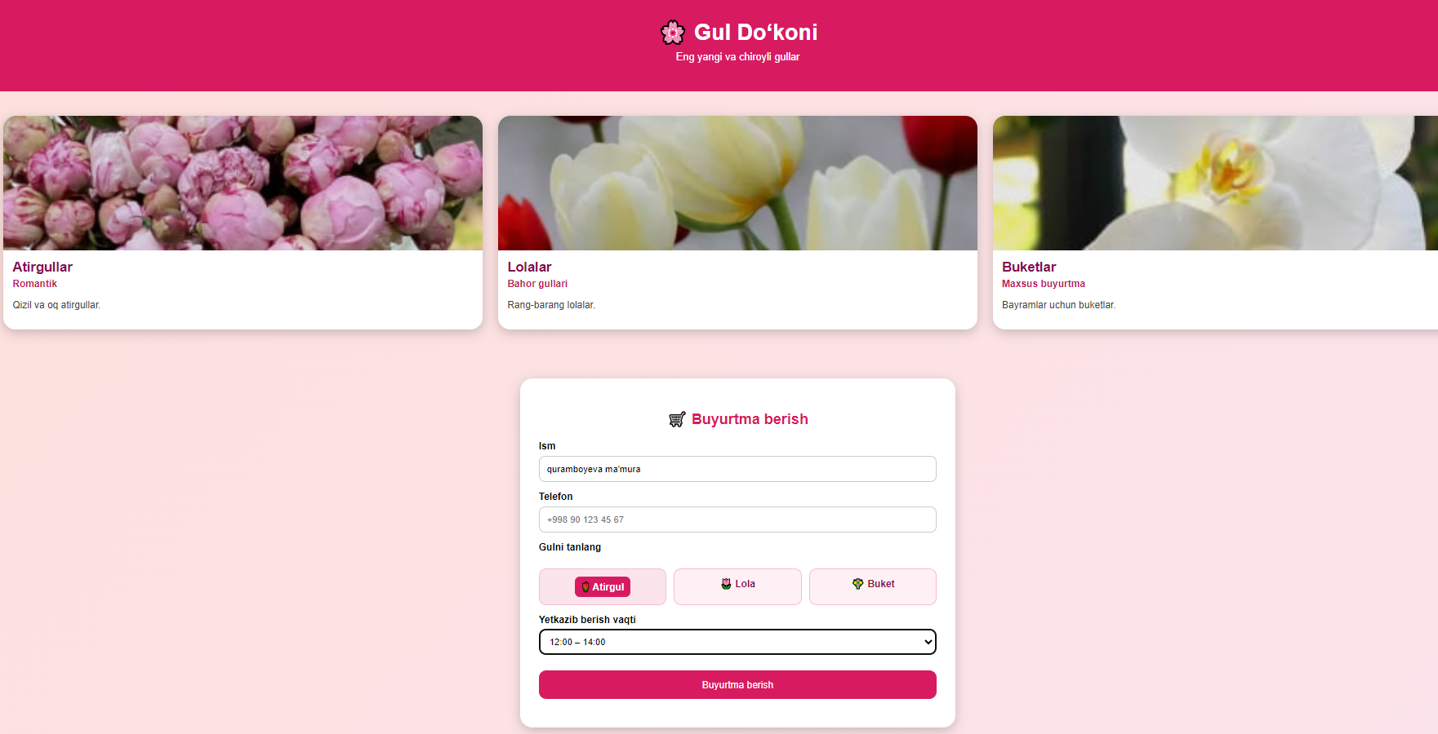

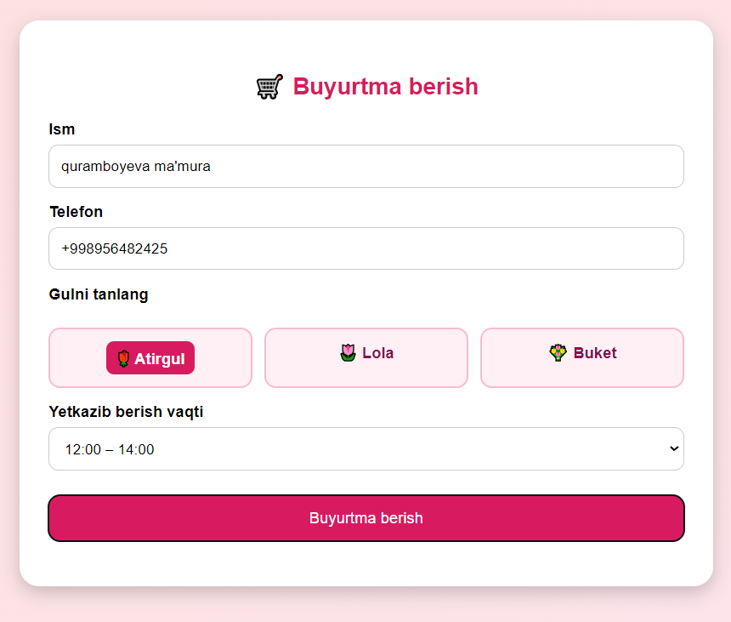

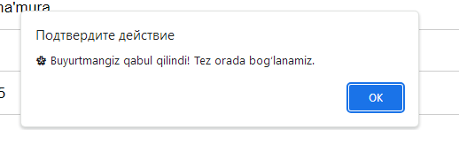

XULOSA
Xulosa qilib aytganda, JavaScript orqali forma validatsiyasi web-saytlar uchun juda muhim jarayondir. U foydalanuvchi tomonidan yuborilayotgan ma’lumotlarning to‘g‘ri va xavfsiz bo‘lishini ta’minlaydi. Validatsiya yordamida xatoliklar darhol ko‘rsatiladi, bu esa saytni qulay, tezkor va ishonchli qiladi. JavaScript validatsiyasi serverga bo‘lgan yukni kamaytirib, foydalanuvchi tajribasini yaxshilaydi va noto‘g‘ri ma’lumotlarning oldini oladi.

